**16)Multimedia Network**

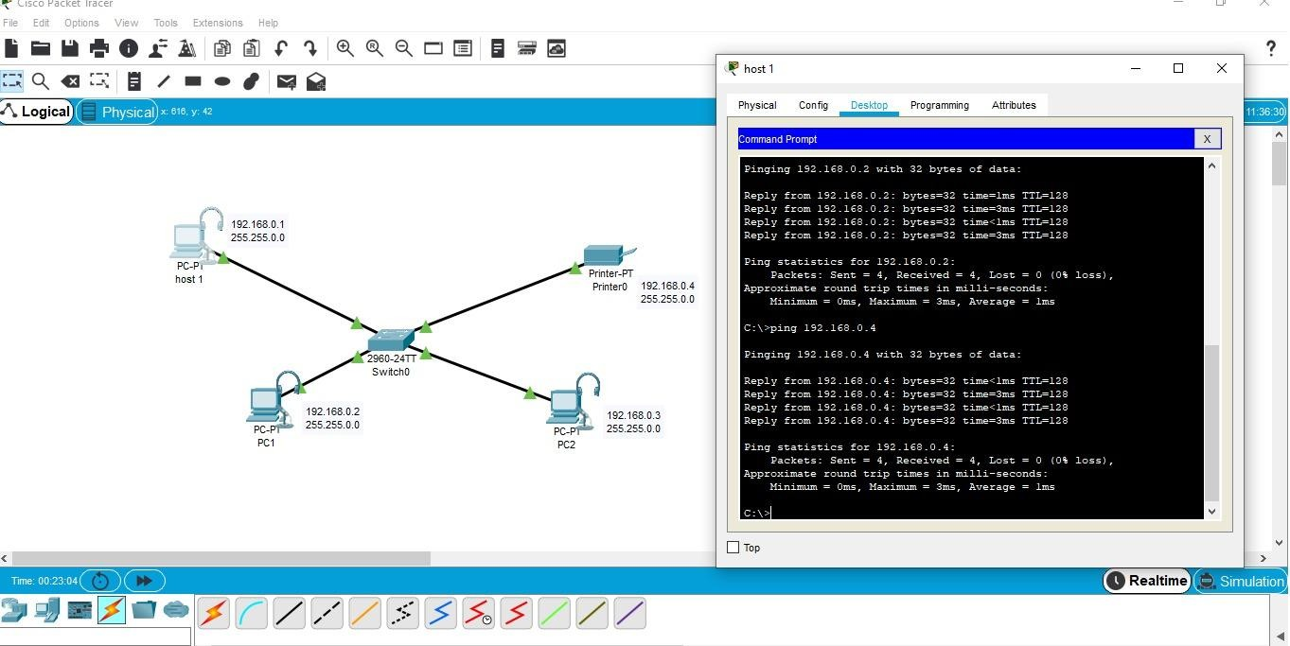

**17)AAA Local & Server Authentication Configuration**

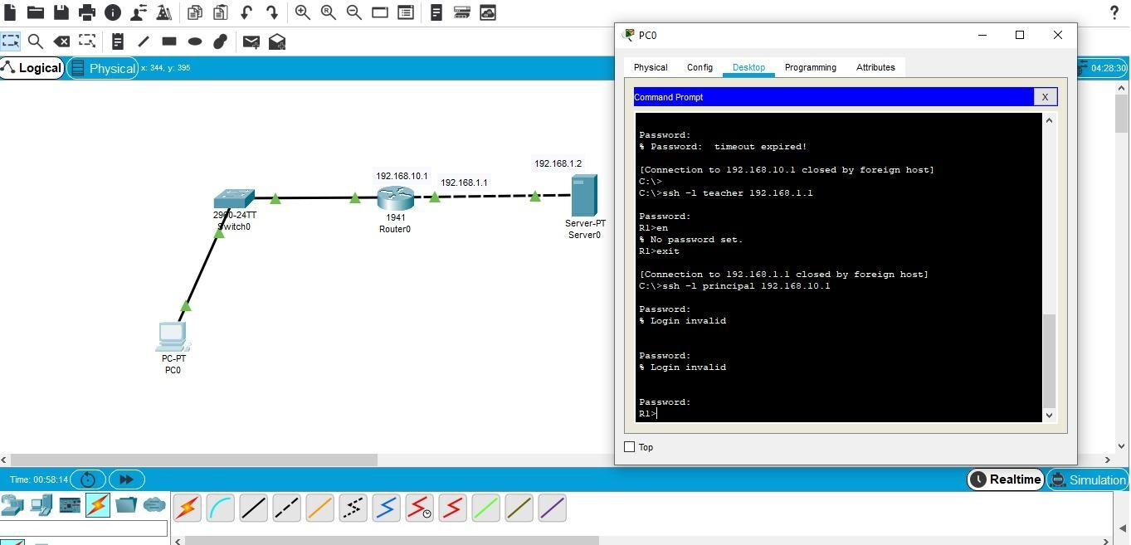

**18)WPA Security & Radius Server**

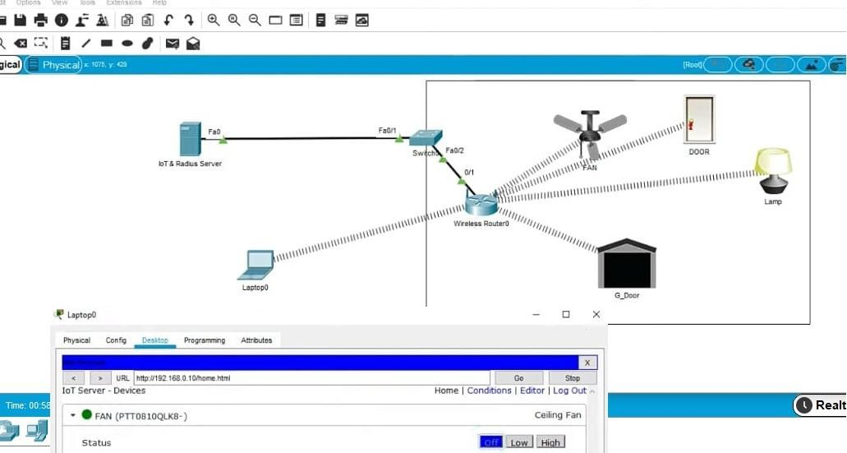

**19)WLAN Using Cisco Packet Tracer**

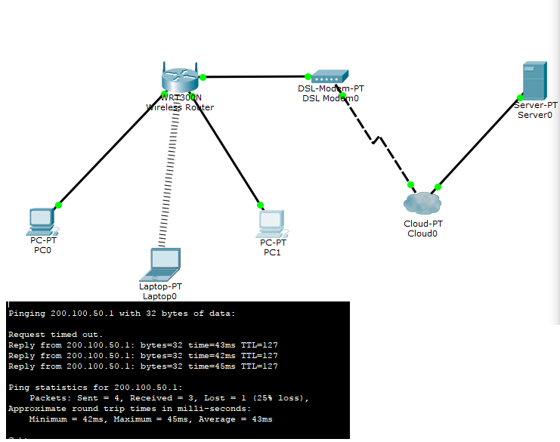

**20) Control of Fan, Light, Window & Application of Using Cisco Packet Tracer**

